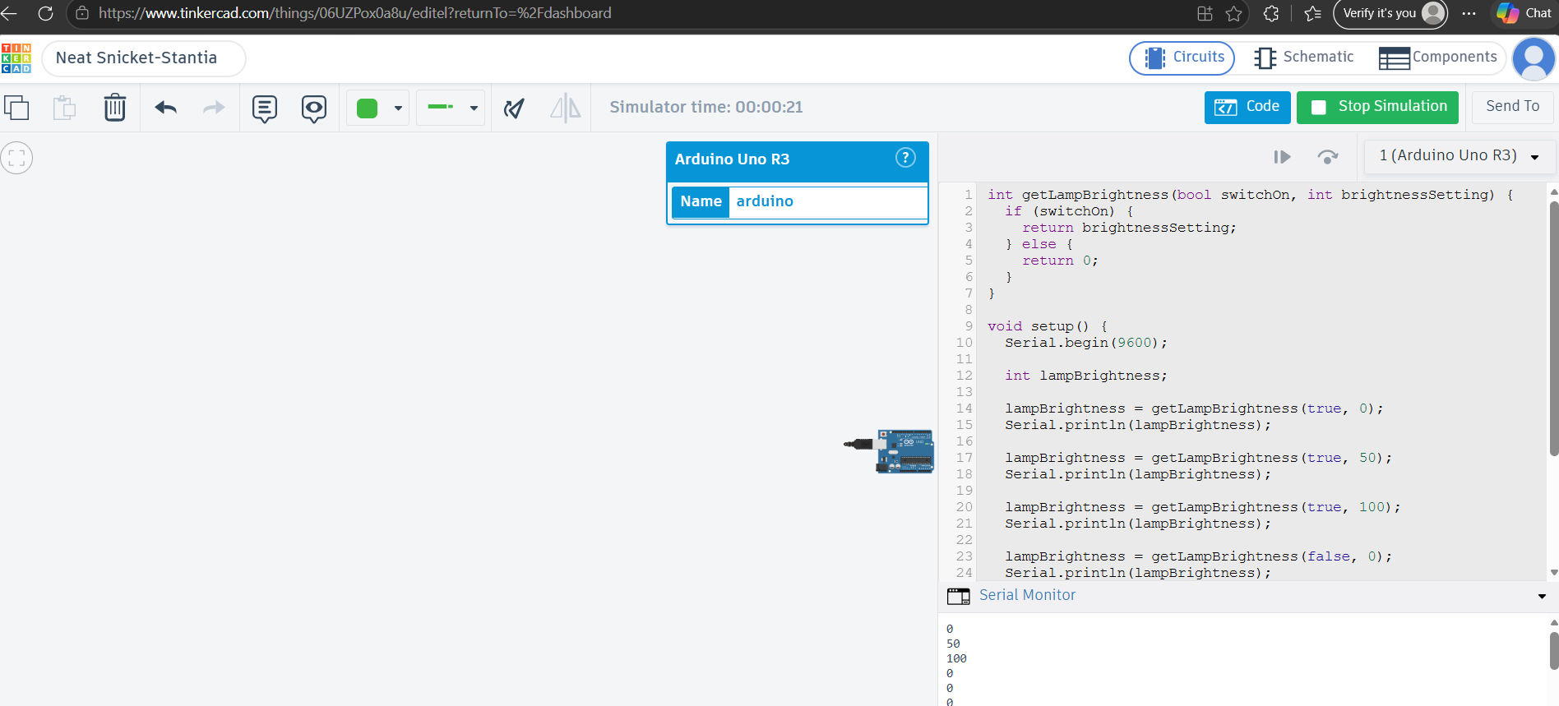
Enad, Cydee S. | BCA188| BSCA
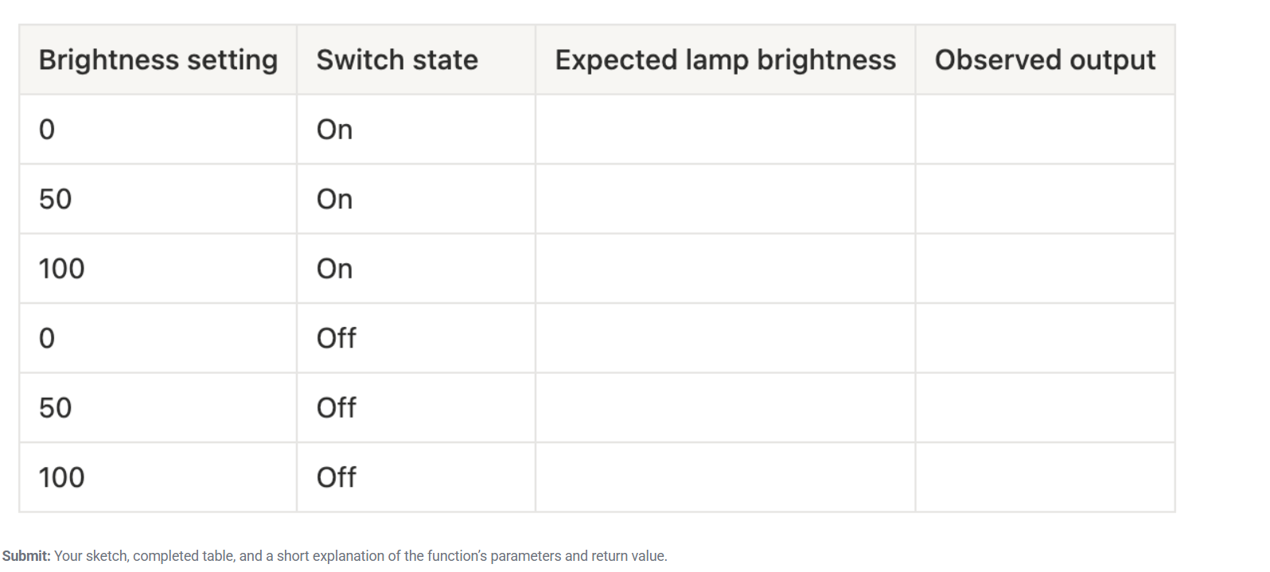

Explanation
getLampBrightness(bool switchOn, int brightnessSetting) takes two parameters:
-switchOn — a bool representing whether the lamp's power is on (true) or off (false).
-brightnessSetting - an int representing the desired brightness level (0–100).
Inside the function, an if statement checks switchOn. If it's true, the function returns brightnessSetting unchanged, the lamp shows whatever level was set. If it's false, the function returns 0, regardless of what brightnessSetting is the lamp is dark, but the brightness setting itself isn't touched or reset, only the light output is forced to zero. This mirrors a real lamp: the dial position stays wherever you left it even when you flip the switch off; the switch simply cuts the current so no light comes out.
The return value (an int) is captured in setup() inside the variable lampBrightness, which is then printed with Serial.println().
Coding Check
1. Data type: int. Variable name: brightnessSetting. Initial value: 75. To change it: brightnessSetting = 50;
2. switchOn only has two possible states (on/off), so bool fits. brightnessSetting needs a range of numbers (0-100), so it needs int.
3. Output is 0, since the switch is off.
4. No, they're different variables. C++ cares about capitalization, so switchOn and switchon aren't the same thing.
5. It's passed a bool and an int, and it returns an int.
6. No. Variables declared inside setup() only exist inside setup(). loop() can't see them. It would have to be declared globally (outside both functions) to be shared.

0
0
0
100
50
0
0
0
0
100
50
0

